assignment 3A
CISP430
FALL 2003
MW 5:30PM – 6:45PM
INSTRUCTOR: M. DIXON

STACK AND QUEUE
clarence mitchell

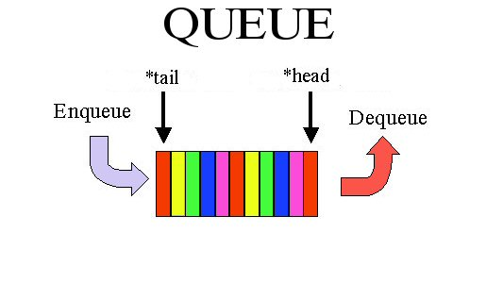
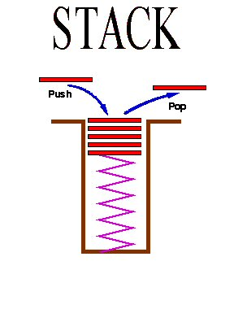
ASSIGNMENT 3A
STACK AND QUEUE
clarence mitchell

assignment OVERVIEW

description
This assignment implements the stack and queue classes using a link list base class.

DUE DATES
Date | Date
First Due Date | Monday, September 22, 2003
Last Due Date | Wednesday, September 24, 2003

list

DOMAIN
Consist of
- A collection of component values (Items).
- An implicit list cursor in the range 1 through n + 1, where n is the current length of the list.

STRUCTURE
A linear, sequential access structure of varying length

NOTE
Conceptually, there is no upper bound on the length of a list. But in practical terms, a computer’s memory size is bounded and so is the length of a list.

operations
Create( ) | Creates an empty list (NOTE: This is included for the purpose of documentation. An the function of the create is in the object constructor)
CurrentItem( ) | Returns the item pointed to by the CurrentItem Pointer
Delete( ) | Deletes the item pointed to by the CurrentItem pointer and moves pointer to next item in list
EndOfList( ) | Returns TRUE if CurrentItem pointer is at last item in list
InsertAfter ( ) | Inserts Item AFTER the CurrentItem pointer
InsertBefore( ) | Inserts Item BEFORE the CurrentItem pointer
IsEmpty( ) | Returns TRUE if list is empty
IsFull( ) | Returns TRUE if list is full
MoveFirst( ) | Moves the CurrentItem pointer to the first item in the list
MoveLast( ) | Moves the CurrentItem pointer to the last item in the list
MoveNext( ) | Moves the CurrentItem pointer to the next item in the list

STACK

DOMAIN
Consist of a collection of component values (Items).

STRUCTURE
A list, maintained in LIFO order so that only the most recently inserted item is accessible.

NOTE
Conceptually, there is no upper bound on the length of a stack. But in practical terms, a computer’s memory size is bounded and so is the length of a stack.

operations
Create( ) | Creates an empty stack. (NOTE: This is included for the purpose of documentation. An the function of the create is in the object constructor
IsEmpty( ) | Returns TRUE if stack is empty
IsFull( ) | Returns TRUE if stack is full
Pop( ) | Removes a item from top of stack
Push( ) | Inserts item at top of stack
Top( ) | Returns item on top of stack, but item remains on stack

QUEUE

DOMAIN
Consist of a collection of component values (Items).

STRUCTURE
A list, maintained in FIFO order so that insertions take place at the rear and deletions take place at the front.

NOTE
Conceptually, there is no upper bound on the length of a queue. But in practical terms, a computer’s memory size is bounded and so is the length of a queue.

operations
Create( ) | Creates an empty queue. (NOTE: This is included for the purpose of documentation. An the function of the create is in the object constructor
Dequeue( ) | Removes item from front of queue
Enqueue( ) | Inserts item at end of queue
Front( ) | Returns item at front of queue, but item remains in queue
IsEmpty( ) | Returns TRUE if queue is empty
IsFull( ) | Returns TRUE if queue is full

